**Exercise 5: Configuring the Spring IoC Container**

**Output**

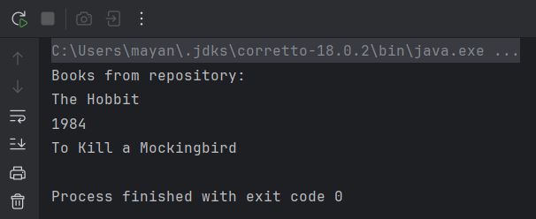

**Exercise 7: Implementing Constructor and Setter Injection**

**Output**

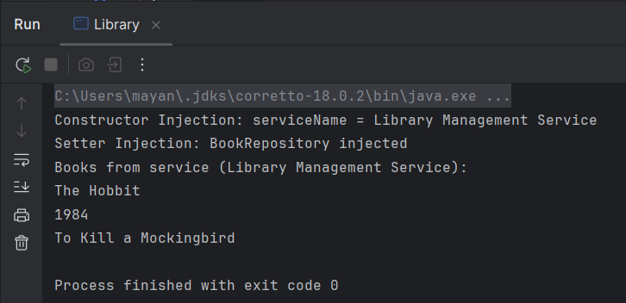

**Exercise 8: Implementing Basic AOP with Spring**

**Output**

